Graphic Novels 101
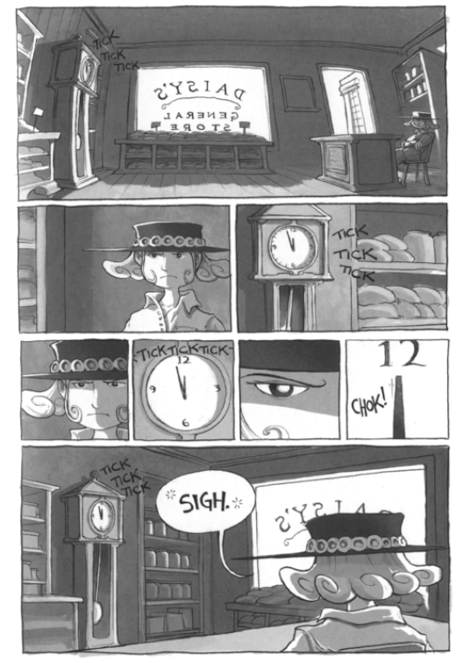
- What can we assume is the name of the girl featured on this page?____________________________________
- How is this girl feeling? What could be causing her to feel this way?____________________________________
___________________________________________________________________________________________

- What is the difference in view (perspective) from the top panoramic scene and the bottom one? What affect does it have?________________________________________________________________________________
___________________________________________________________________________________________
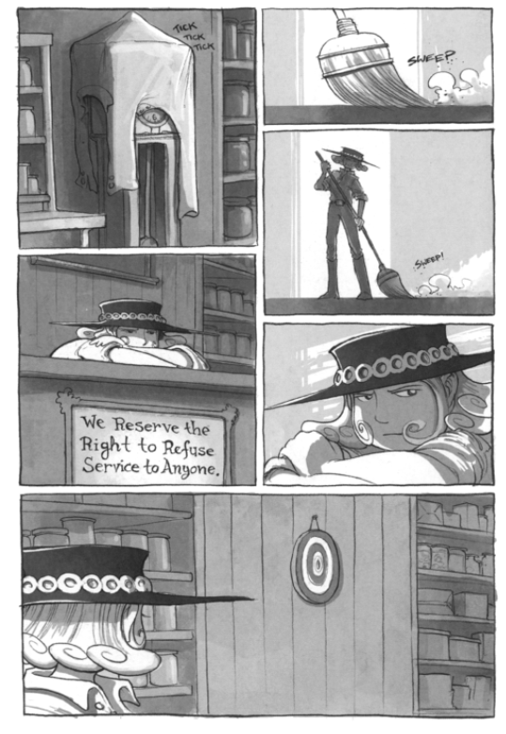
- Why is there a shirt draped over the clock? ________________________________________________________

- Number each panel (separate image) in the order you think each should be read. Use numbers 1-6.

- According to the girl, what is the most interesting item in this space? ___________________________________

Source: Daisy Kutter: The Last Train (Book 1). Viper Comics. March 30, 2005.
Now you try…we are giving you the third page of this story because we want you to try creating part of the story yourself! You can do this in one of two ways that we will describe to you now: drawing your own panels; or creating your own comic script page. You can use the space below for you creation:
LAYOUT

Graphic novel/ comic terms and concepts
Panel: ______________________________________________________________________________________
___________________________________________________________________________________________
- The spatial arraignment allows for immediate contrast between of present and past
- Unlike other visual media, transitions are instantaneous and direct but the exact timing of the readers’ experience is determined by focus and reading speed.
Frame:______________________________________________________________________________________
Gutter:______________________________________________________________________________________
Bleed: ______________________________________________________________________________________
Foreground: _________________________________________________________________________________
Midground: Allows centering of image by using natural resting place for vision. The artist deliberately decided to place the image where the view would me most likely to look first. Placing an image off-center, or near the top or bottom can be used to create visual tension but using the midground permits the artist to create a more readily accepted image.
Background: Provides additional, subtextual information to the reader
Graphic weight:______________________________________________________________________________
___________________________________________________________________________________________
- The use of light and dark shades, dark toned images or high contrast images draw the eye more than light or low contrast images do
- A pattern or repeated series of marks
- Colors that are more brilliant or deeper than others on the page
FIGURES
Faces: Faces can be portrayed in different ways. Some depict an actual person, like a portrait; others are iconic, which means they represent a group of people.
- They can be dramatic by__________________________________________________________
- They can be drawn without much expression or detail, called ____________________________
This requires the audience to imagine what the character is feeling without telling them.
Hands/Feet: _________________________________________________________________________________
___________________________________________________________________________________________
- Hands raised means_______________________________
- Wringing of hands means __________________________
- Hands over mouth means ___________________________
- Turned feet mean__________________________________
- Feet with motion strikes means_______________________
TEXT
Captions:____________________________________________________________________________________
Speech balloons: _____________________________________________________________________________
- External dialogue: spoken between characters
- Internal dialogue: thoughts enclosed in a bubble that has a series of dots or bubbles going up to it
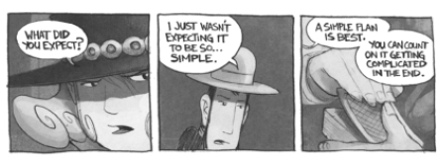
Special-effects lettering: _______________________________________________________________________

Directions: Analyze the open-blank faces above. Then, create captions, speech balloons, and thought bubbles that clearly tell a story within the frames. You must use all captions, thought, and speech bubbles featured.

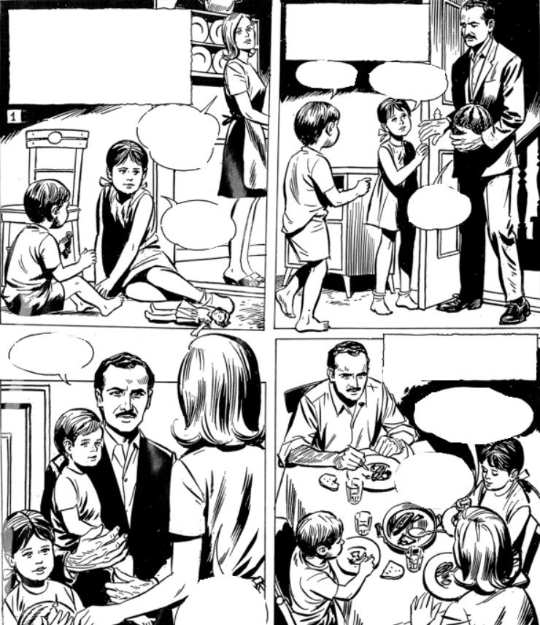

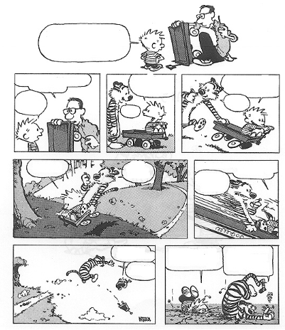

Source: AlmaBoheme.blogspot.com

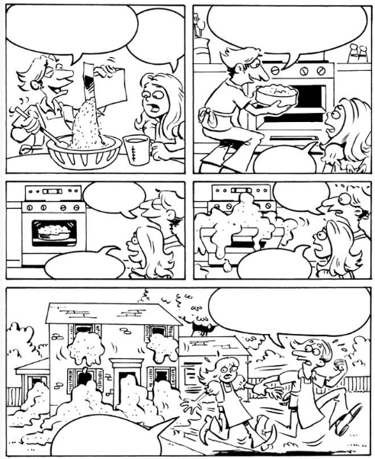

Doverpubli

Source: DoverPublications.com
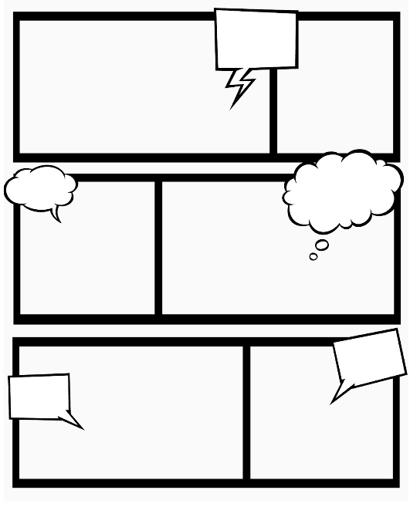

Source: AlmaBoheme.blogspot.com

