Name _______________________________________________________________________________ Period ________
Comic Books and Chemical Reactions
Read Comic #1: Dragonball Z, and then answer the following questions.
- In simple terms, what happened in this comic?
_________________________________________________________________________________________________________________
- What type of reaction is being depicted in the comic? Think creatively.
________________________________________________________________________________________________________
- This particular comic has 3 pages. On which page are the reactant(s) shown? ________________

- This particular comic has 3 pages. On which page are the product(s) shown? ________________

- According to the reaction of the characters, does this type of reaction absorb energy or release it?
________________________________________________________________________________________________________
- Which of the reactions below is an example of the reaction shown in Comic #1?
  - H₂SO₃ → SO₂ + H₂O
  - 2H₂ + O₂ → 2H₂O
  - H₂SO₄ + 2NaOH → Na₂SO₄ + 2H₂O
  - CH₄ + 2O₂ → CO₂ + 2H₂O

Read Comic #2: Fantastic Four, and then answer the following questions.
- Based on the first frame of the comic, what is the Human Torch’s superpower?

_________________________________________________________________________________________________________________

- What type of reaction is this an example of? ______________________________________________________________

- If the Human Torch is truly going through the type of reaction you mentioned above, what are the products he should be releasing in the process?

- In the last frame, the Human Torch is shown fighting a space alien. Can you think of a way that the alien could stop the Human Torch? (Hint: Think of the chemical reaction behind his super power!)
_________________________________________________________________________________________________________________
- At the bottom of the first page, Human Torch is shown flying into the sky, using his fire as a jet. Why wouldn’t he be able to fly into outer space? (Hint: Think of the chemical reaction!)
_________________________________________________________________________________________________________________
- Which of the reactions below is an example of the reaction shown in Comic #2?
  - H₂SO₃ → SO₂ + H₂O
  - 2H₂ + O₂ → 2H₂O
  - H₂SO₄ + 2NaOH → Na₂SO₄ + 2H₂O
  - CH₄ + 2O₂ → CO₂ + 2H₂O

Read Comic #3: Spider Man, and then answer the following questions.
- What is wrong with Peter Parker (the main character) in this comic strip?
_________________________________________________________________________________________________________________
- What is making Peter Parker look evil and act violent in the comic?
_________________________________________________________________________________________________________________
- How does Peter Parker attempt to solve this problem?
_________________________________________________________________________________________________________________
- What has happened to the symbiote (dark slime) by the end of the comic?
_________________________________________________________________________________________________________________
- What type of reaction is being portrayed by this comic? Explain why!
_________________________________________________________________________________________________________________
_________________________________________________________________________________________________________________

- What are the final products of the reaction in the comic? (Hint: They aren’t chemicals. Think creatively.)
_________________________________________________________________________________________________________________

- According to the comic, what is one way to start this type of reaction? (How did Peter Parker do it?!)
_________________________________________________________________________________________________________________

- Which of the reactions below is an example of the reaction shown in Comic #3?
  - H₂SO₃ → SO₂ + H₂O
  - 2H₂ + O₂ → 2H₂O
  - H₂SO₄ + 2NaOH → Na₂SO₄ + 2H₂O
  - CH₄ + 2O₂ → CO₂ + 2H₂O
Comic 1: DRAGONBALL Z
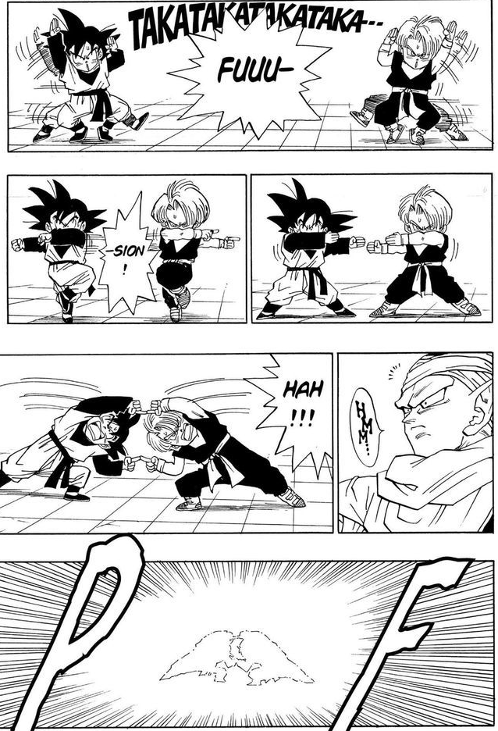
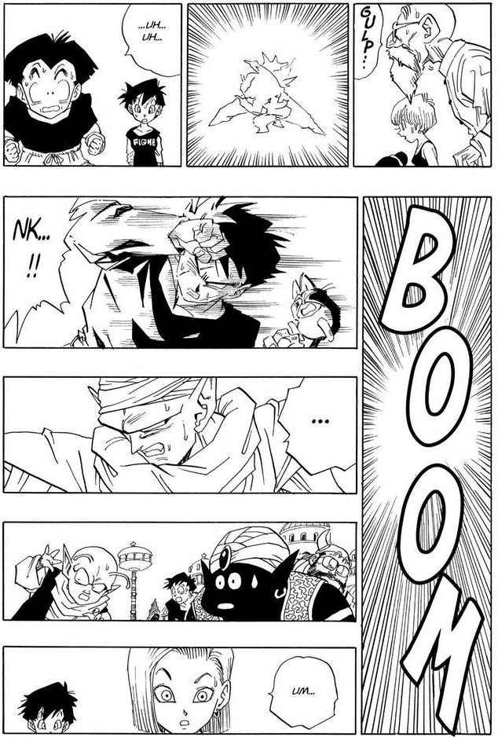
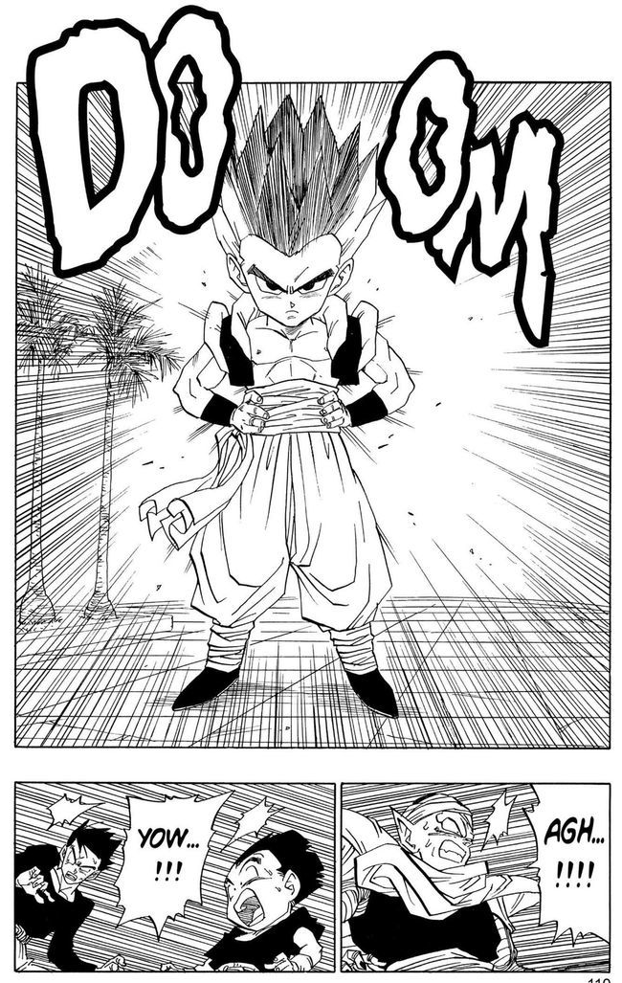
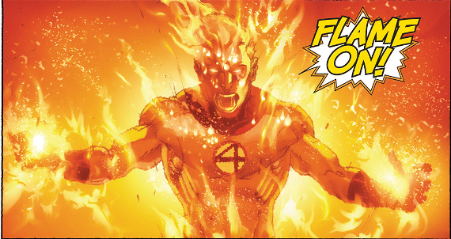
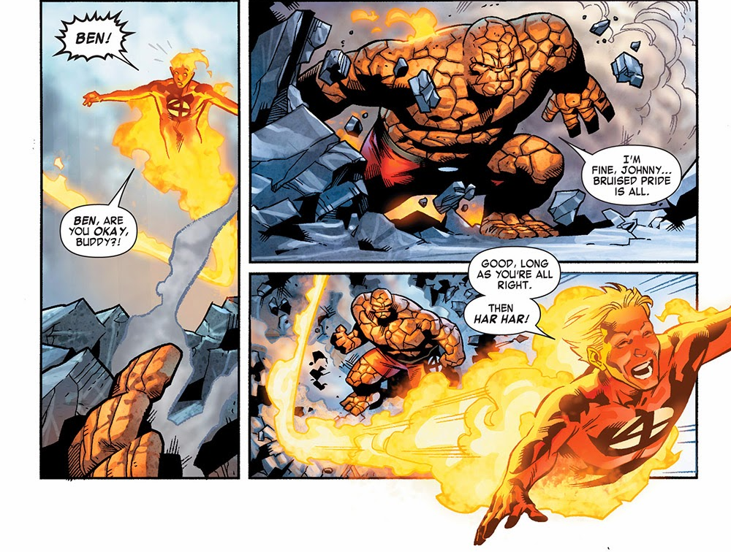
Comic 2: FANTASTIC FOUR
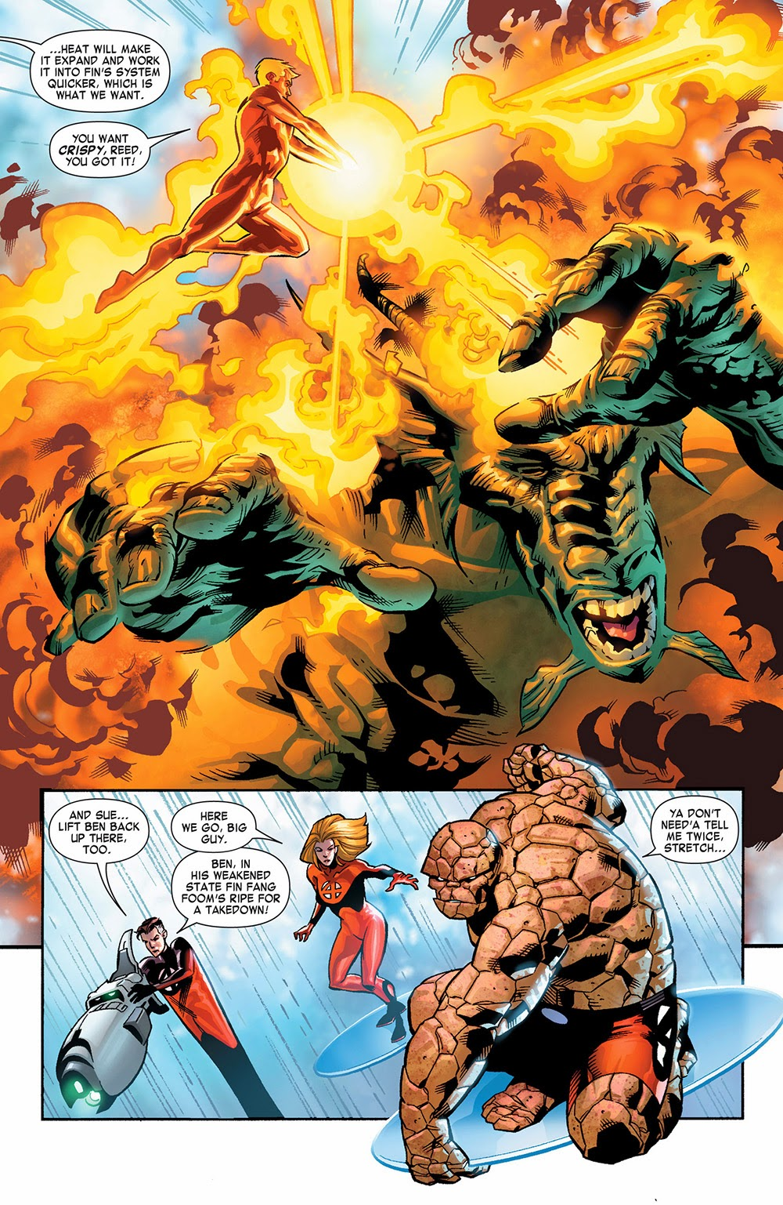
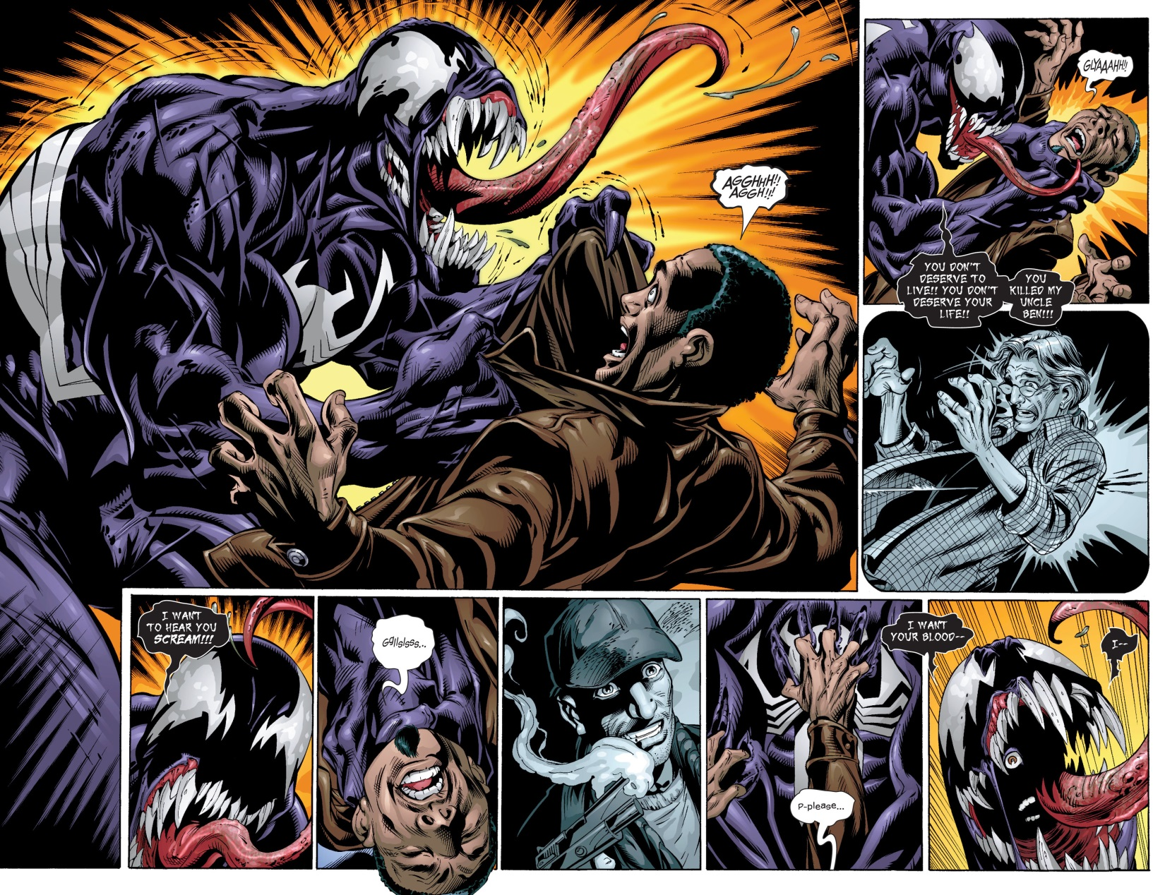
Comic 3: SPIDER MAN



